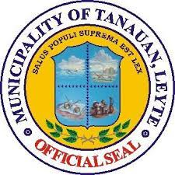Republic of the Philippines

**OPEN SEPAK TAKRAW TOURNAMENT**

Tanauan Leyte

**Certificate of Appreciation**

This Certificate is Awarded to

NAME

"With heartfelt gratitude, we recognize your outstanding performance and dedication at the Open Sepak Takraw Tournament. Your skill and sportsmanship not only inspire us but also elevate the spirit of the game. Thank you for being an integral part of this event. Congratulations!"

Given this dd day of MM YY at (Location of Ceremony), Tanauan Leyte